<Project Name>

Architecture Design

**Architecture Design Template Instructions**

**(Please remove this section before completion of template)**

The Architecture Design document should include current states and the future states of the project, i.e. network, hardware and interfaces. This document needs to review all system, environment and application needs to implement as effectively as possible.

Be sure to maintain version control as the analysis is modified and/or edited.

All instructions within the template are italicized within the document.

Any examples are in a red font.

Any portion of the template that does not fit or pertain to your project should be documented that it was reviewed and is not relevant. See below for requirements for a project and deliverable approvals.

Be sure to unlock table of contents by selecting TOC then Ctrl-Shift-F11 to enable TOC updating in Word docx.

| **Project Deliverable** | **Requirements by Project Size** | | |  |  |
| --- | --- | --- | --- | --- | --- |
| **Pre-Project Planning Phase** | **Large** | **Medium** | **Small** | **Requirements** | **Approvals** |
| **Architecture Design Document (SDLC)** | **O** | **O** | **O** | **This deliverable is optional for all project sizes, unless requested by the Sponsor, Steering Committee, or IT management.** | **The Architecture Design should be approved by the Sponsor and the Steering Committee, at a minimum.** |

Table of Contents

1. Introduction 2

1.1. Purpose 2

1.2. Assumptions 2

2. Version Control 3

3. Systems Architecture 4

3.1. Network Architecture 4

3.1.1. Current Process 4

3.1.2. Proposed Process 5

3.2. Server Architecture 5

3.2.1. Current Process 5

3.2.2. Proposed Process 5

3.3. Interface Architecture 6

3.3.1. Current Process 6

3.3.2. Proposed Process 6

4. Security 7

5. Approval 8

# Introduction

## Purpose

*The purpose of Architecture Design is to:*

* *Meet system requirements and objectives*
* *Enable flexible partitioning of the system*
* *Reduce cost of maintenance and evolution*
* *Increase reuse and integration*

*A good architecture design provides for easy mapping to the user's requirements and the validation tests of the user's requirements.*

*Documenting architecture facilitates communication between stakeholders, documents early decisions about high-level design, and allows reuse of design components and patterns between projects*.

## Assumptions

*This document assumes.....*

# Version Control

|  |  |  |  |
| --- | --- | --- | --- |
| Version | Date | Person | Change |
| 1.0 |  |  | Initial Document Creation |
|  |  |  |  |
|  |  |  |  |
|  |  |  |  |

# Systems Architecture

Provide the diagram(s), storyboard(s), flowchart(s), and/or any other visually descriptive documents with corresponding narrative that depicts the following aspects of the application and/or system.

The following parameters should be considered and provided for, in Architecture Design:

* Performance: Localize operations
* Security: Use of layered architecture with critical assets in inner layers
* Safety: Isolate safety-critical components
* Availability: Include redundant components in the architecture
* Maintainability: Use of self-contained components
* Requirements Mapping: Provide partitioning algorithms/processes and allocate all present/foreseeable requirements into discrete partitions so that the communication between components and between the user/system is optimized.
* System Partitioning: Partition large systems into (successive layers of) subsystems and components each of which can be handled by an individual or team of subordinate architects
* Database Schemas: The structure of the database.
* Solution Alternatives: Identify alternative system concepts, configuration items and system elements.

## Network Architecture

# Current Process

Provide the diagram(s) storyboard(s), flowchart(s), and/or any other visually descriptive documents with the corresponding narrative of the current network architecture if available.

*Note: The diagram below has been provided for illustrative purposes only and should be replaced with diagram specific to the project.* 

# Proposed Process

Provide the same as above for the proposed network architecture.

## Server Architecture

# Current Process

Provide a diagram and narrative of the current server architecture if available.

*Note: The diagram below has been provided for illustrative purposes only and should be replaced with diagram specific to the project.*



# Proposed Process

Provide the same as above for the proposed server architecture.

## Interface Architecture

# Current Process

Provide a diagram storyboard(s), flowchart(s), and/or any other visually descriptive documents with the narrative of the current interface architecture if available.

*Note: The diagram below has been provided for illustrative purposes only and should be replaced with diagram specific to the project.*

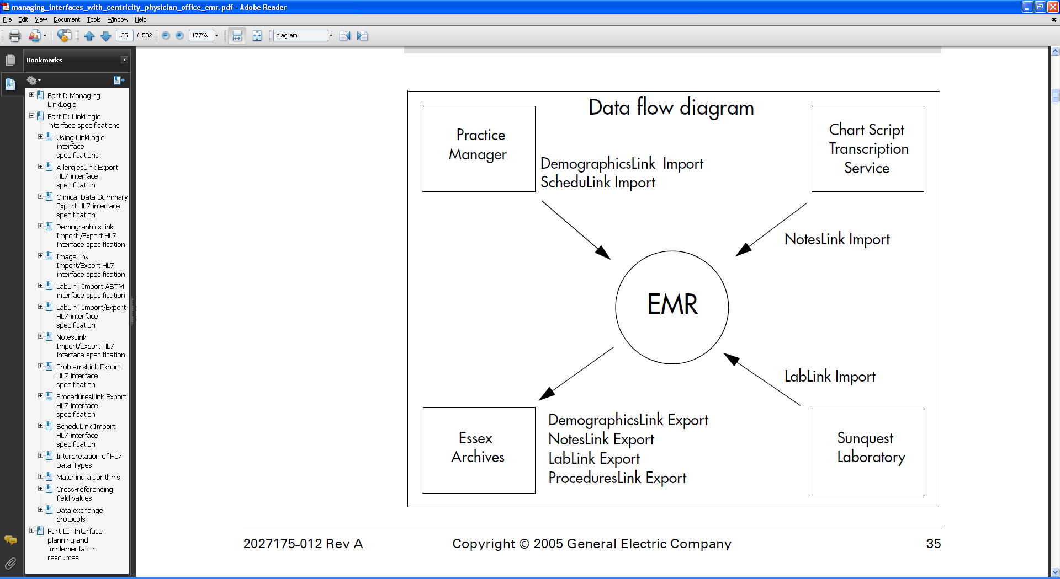

# Proposed Process

Provide the same as above for the proposed interface architecture.

# Security

Please document any additional security needed due to any of the architecture identified in the above steps.

**Approvals**

The individuals below agree that they have reviewed and approved the plan outlined in this Support Documentation.

|  |  |  |  |
| --- | --- | --- | --- |
| APPROVED BY: | | | |
| Function Role | Name and Title | Signature | Date |
|  |  |  |  |
|  |  |  |  |
|  |  |  |  |
|  |  |  |  |